**Digital Display**

**Alarm Clock**

**Genesis C. Urmeneta**

**Jerome M. Larua**

**Cord Ian Moraleta**

#include <LiquidCrystal.h>

LiquidCrystal lcd(7, 6, 5, 4, 3, 2);

int starttime;

int activetime;

int prevoustime = 0;

int hours = 0;

int mins = 0;

int ahours = 0;

int amins = 0;

void setup()

{

  lcd.begin(16, 2);

  lcd.clear();

  Serial.begin(9600);

  pinMode(13, INPUT);

  digitalWrite(13, HIGH);

  pinMode(11, INPUT);

  digitalWrite(11, HIGH);

  pinMode(10, INPUT);

  digitalWrite(10, HIGH);

   pinMode(8, INPUT);

  digitalWrite(8, HIGH);

  pinMode(A0, OUTPUT);

  digitalWrite(A0, HIGH);

   pinMode(9, OUTPUT);

  starttime = millis()/1000;

}

void loop()

{

  while(digitalRead(8) == LOW)

  {

    lcd.setCursor(6,1);

    lcd.print("Alarm");

    lcd.setCursor(6,0);

       if(digitalRead(11) == LOW)

    {

     amins++;

    }

    else if (digitalRead(10) == LOW)

    {

      ahours++;

    }

     lcd.setCursor(6,0);

  if(ahours < 10)

  {

    lcd.print("0");

    lcd.print(ahours);

  }

  else

  {

    lcd.print(ahours);

  }

    lcd.print(":");

  if (amins < 10)

  {

    lcd.print("0");

      lcd.print(amins);

  }

  else

  {

      lcd.print(amins);

  }

 if(amins > 59)

     {

      ahours++;

      amins = 0;

     }

     if(ahours > 23)

     {

      ahours = 0;

     }

     delay(500);

     lcd.clear();

  }

  if(digitalRead(13) == LOW)

  {

    lcd.setCursor(5,1);

    lcd.print("Set Time");

    lcd.setCursor(6,0);

     if(digitalRead(11) == LOW)

    {

     mins++;

    }

    else if (digitalRead(10) == LOW)

    {

      hours++;

    }

  }

      activetime = (millis() / 1000) - starttime;

      if(prevoustime < (activetime - 59))

      {

       mins++;

       prevoustime = activetime;

      }

      if(mins > 59)

     {

      hours++;

      mins = 0;

     }

     if(hours > 23)

     {

      hours = 0;

     }

  lcd.setCursor(6,0);

  if(hours < 10)

  {

    lcd.print("0");

    lcd.print(hours);

  }

  else

  {

    lcd.print(hours);

  }

    lcd.print(":");

  if (mins < 10)

  {

    lcd.print("0");

      lcd.print(mins);

  }

  else

  {

      lcd.print(mins);

  }

if(ahours == hours && amins == mins && amins != 0)

{

  tone(9, 1000, 200);

  delay(200);

  noTone(9);

delay(200);

}

else

{

    delay(300);

}

  lcd.clear();

  Serial.println(mins);

  Serial.println(hours);

  Serial.println("");

  Serial.println(amins);

  Serial.println(ahours);

  Serial.println("");

  Serial.println(activetime);

  Serial.println(prevoustime);

  Serial.println(starttime);

  Serial.println("");

}

**Circuit**

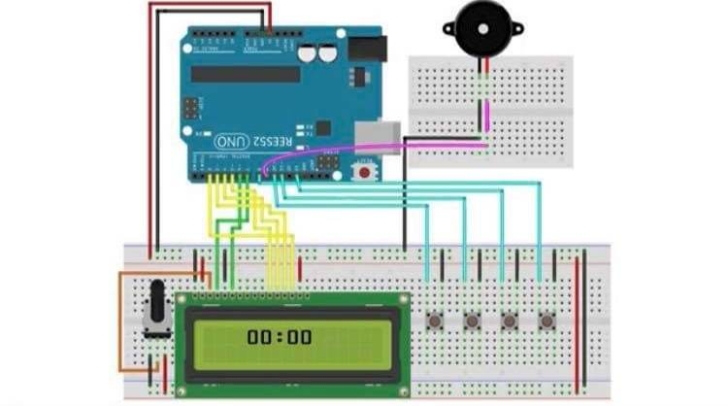

**Material**

1. Arduino Uno with USB Cable

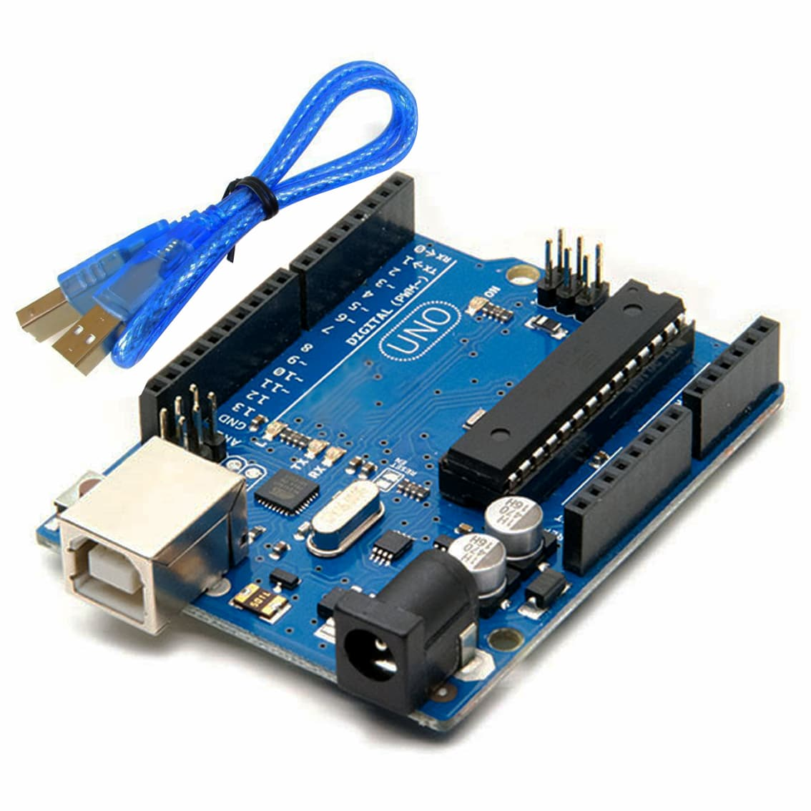

1. LCD 16x2 Display Module

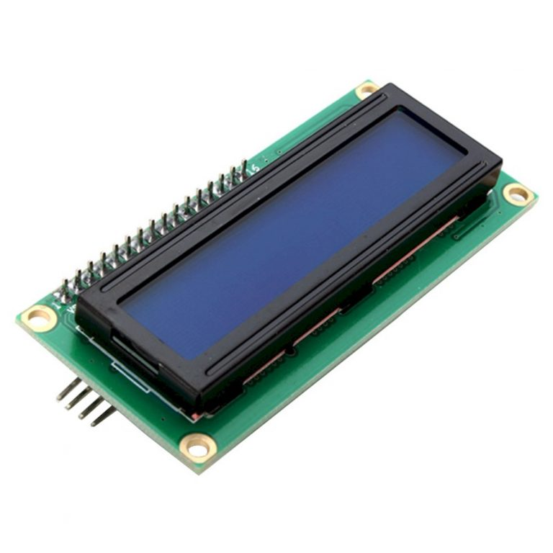

1. Potentiometer

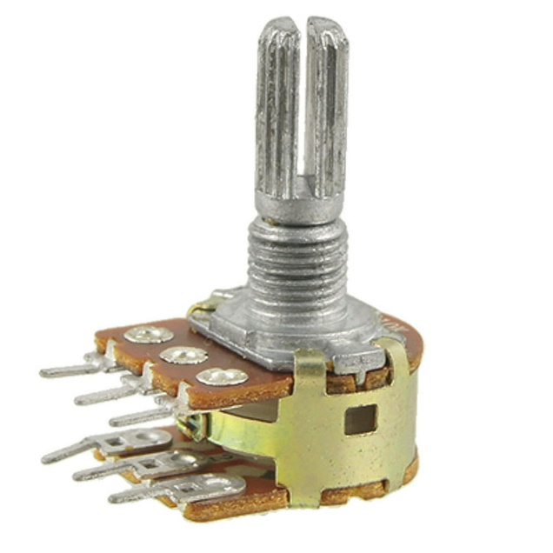

1. Breadboard

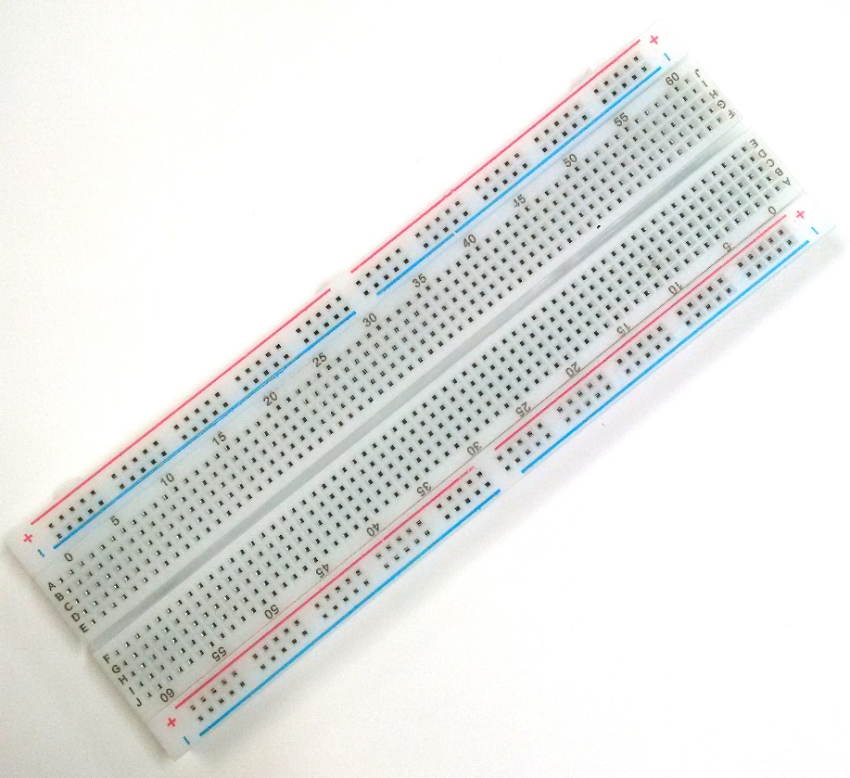

1. Jumper Wires Male to Male

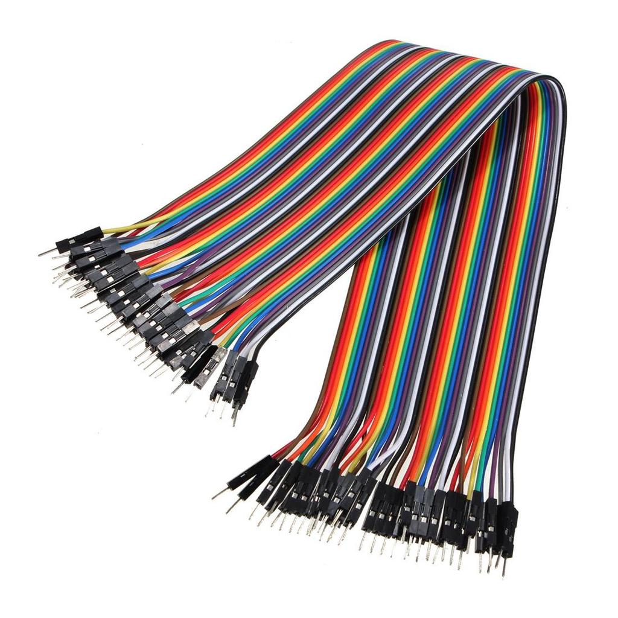

1. Jumper Wires Male to Female

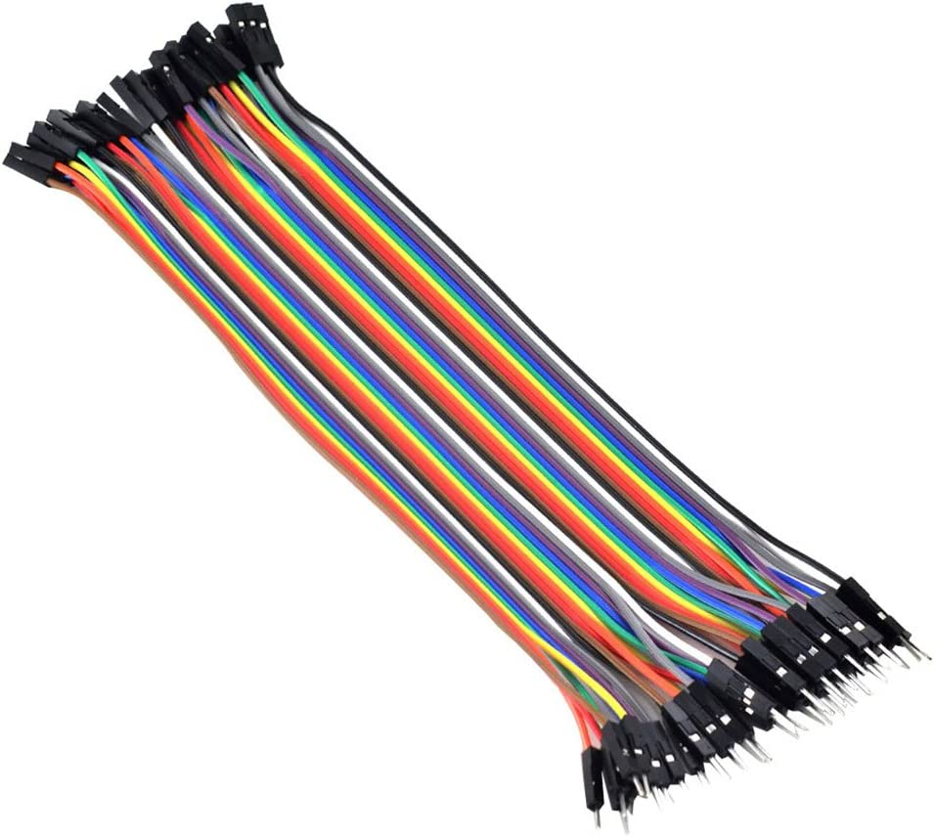

1. Push-Button

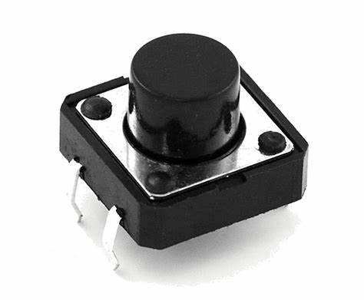

1. Buzzer B10

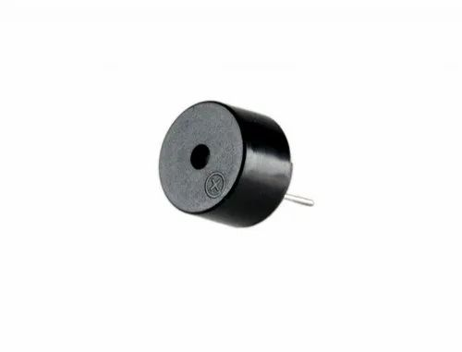

1. Single Strand Wire

